ArtworkTitle
Medium
ArtistName

ArtistContactInfo (phone and/or email) $Price/NFS
How to Use this template:  For each label, add the correct information for you and your artwork as shown in the example above.  Print the page (white card stock or thick paper works best). Cut out the individual label(s). | 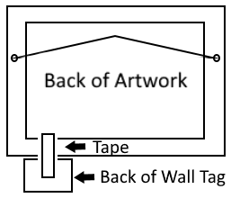  Help protect our gallery hosts walls!!  Use tape (low tack painters or artists tape works great) and tape this label directly to the bottom of the artwork (see diagram). Please do NOT tape your tag directly to the wall to prevent wall damage when the tag is removed.

