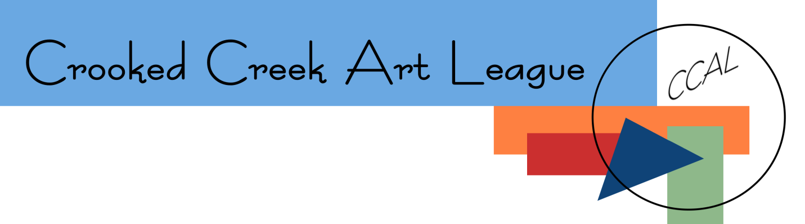
November 2023 President’s Letter

Greetings, CCAL Members!

With Thanksgiving right around the corner, I am spending more time thinking about how grateful and blessed I am. Amid the trials and challenging circumstances that seem to be all around us, it’s sometimes hard to remember to count our blessings. Even though life is not always easy, I keep coming back to feeling grateful for all the good things in my life.

One of those good things is being a member of the Crooked Creek Art League. Since joining the league, I have had the opportunity to meet many people who share a common interest with me. I have been encouraged by many as I began my new role as President of the league. I also made new friends and I look forward to spending time with them in the many opportunities the league offers. During this season I hope you will also count your blessings and be able to focus on all we have to be grateful for.

The time between Thanksgiving and Christmas is always a busy time of year. I am hoping you will be able to participate in some of the upcoming events during this time. I have listed events as well as reminders below to help you as you mark your calendar.

- The Still Hopes Exhibition entry deadline of November 21 is fast approaching. Please make sure to register your artwork for this great exhibition. If you are waiting to complete your third meeting requirement, you will be able to log in on Monday night, November 20 after the meeting to get registered.
- The reception for the Still Hopes Exhibition will be on Saturday, December 9, 2023, 4:00pm-6:00pm. The awards ceremony will begin at 5:00pm.
- Mark your calendar for our upcoming Christmas party. It will be held on our regularly scheduled meeting night of December 18, 2023, 5:30pm-8:00pm. The party will be at the Chapin Town Hall Community Room, 157 NW Columbia Avenue, Chapin. A separate email will be sent with all the details.
- If you haven’t seen our newest addition to the Chapin Art Trail, please check out the mural that was painted by CCAL member Nicki Peeples. The mural “Small Town Charm” was dedicated with a ceremony on November 9, 2023. You can find the mural on the northern wall at 115 Clark Street in Chapin.
- We are looking for more exhibition sponsors for our 2023-2024 season. If you know of any people or businesses who might be interested in supporting the league in this way, please let us know as soon as possible.
- Our speaker for the November meeting will be Rick Rhodes. Rick will give pointers for artists on the basics for photographing their artwork as well as talk in detail about the digital image and what makes a quality image.
- Please remember to renew your membership before December 31. Also, consider contributing an extra financial gift to the League to support ongoing operations.
- Our TAP Gallery theme for November is “Autumn.” If you would like to participate in our monthly themed contest, please bring your artwork, along with your gallery wall label, to Monday’s meeting. All artworks will remain on display until January 15.
- Our next workshop that will be offered is with Courtney Trowman, Friday, January 12 through Saturday, January 13. Her workshop is entitled “Collage and Intuitive Abstracts.” Please go online to register.
- Friday, January 26 through Saturday, January 27 will be a watercolor workshop offered by JJ Jiang entitled “The Simplicity of Watercolor Painting.” Please go online under the “workshops” tab to register.
- Don’t forget to sign up to display your artwork in our public galleries. You can do this by going to our website and finding the “Public Galleries Artist Assignment” tab. We are always looking for more members who would like to display their work at various places in town.
- You should have received an emailed copy this past week of the revised Constitution that was approved by the board and recommended to the membership. Please come prepared to vote at the November 20 meeting on the recommended revisions.

As I think about all our members who have given of their time and talent in the past, as well as those who are currently serving the league, I want to thank you all for your service in helping to make this league what it is today. Without your help we would not be able to do all we do! We now have over 160 members and continue to grow. It takes dedicated time and energy to make sure all the avenues that our league offers run smoothly. We have over 30 people who are serving our league in some capacity on a regular basis, including Board members, Committee Members, and our Service and Support Team. Others of you serve on an “as needed” basis when asked to help. I am grateful for the many volunteers this league has and appreciate your willingness to give of your time and talents.

I would like to recognize someone special who has volunteered her time for the league by sending out our mass email correspondence. Donna Reid has been sending out our mass emails since 1999, and for that we are very appreciative. Donna has unfortunately had to step away from the position this year and Jan Lane has stepped in to cover our email correspondence. Thank you, Donna, for your many years of service! We all appreciate the time and effort you gave in serving our league for so many years!

In closing, I would just like to wish everyone a Happy Thanksgiving as you gather with friends and family. I encourage each of you to count your many blessings. Let us also be mindful of those who are facing difficult times in their lives right now and could use a little extra encouragement. I hope to see you at our November meeting as well as our Christmas Party in December!

Sincerely,

Yvonne Beyer
President, CCAL

