SAMPLE for possible public gallery artwork exhibit label.
Just type your information below where indicated, print and cut.

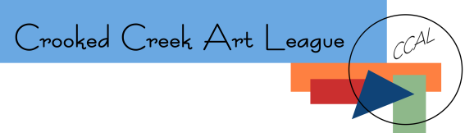
ArtworkTitle
Medium

ArtistName
ArtistContactInfo (phone and/or email) Price

How to Use this template:
For each label, replace the words shown in the example above with the correct information for you and your artwork.
Print and cut out the label (white card stock or thick paper works best).
Help protect our gallery hosts walls!! Use tape (low tack painters or artists tape works great) and tape this label directly to the bottom of the artwork (see diagram below). Please do NOT tape your tag directly to the wall to avoid wall damage when the tag is removed.
